**Tugas week 9 advanced bda Christopher Darren 00000054804**

1. Which two companies have the highest average profit generated (one possible criterion for promotion)? **Orion France** and **Orion USA**

Image of your reported answer

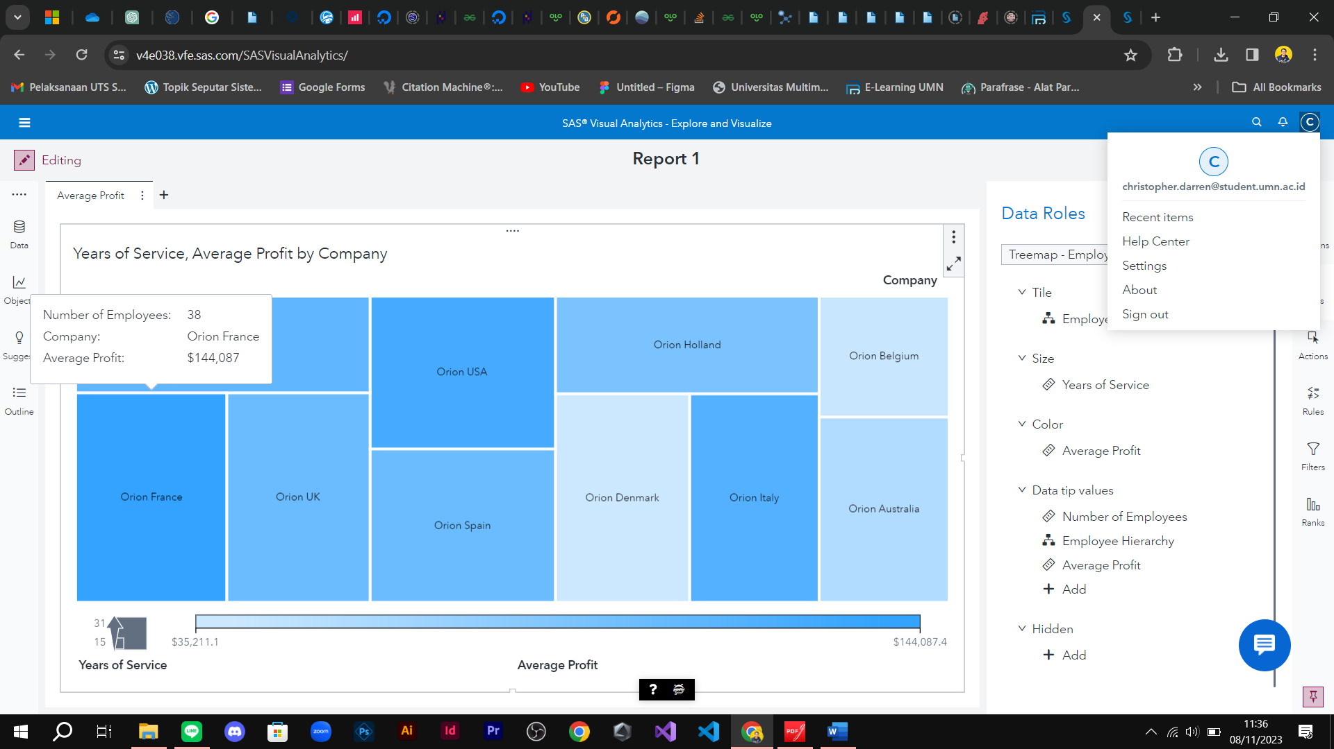

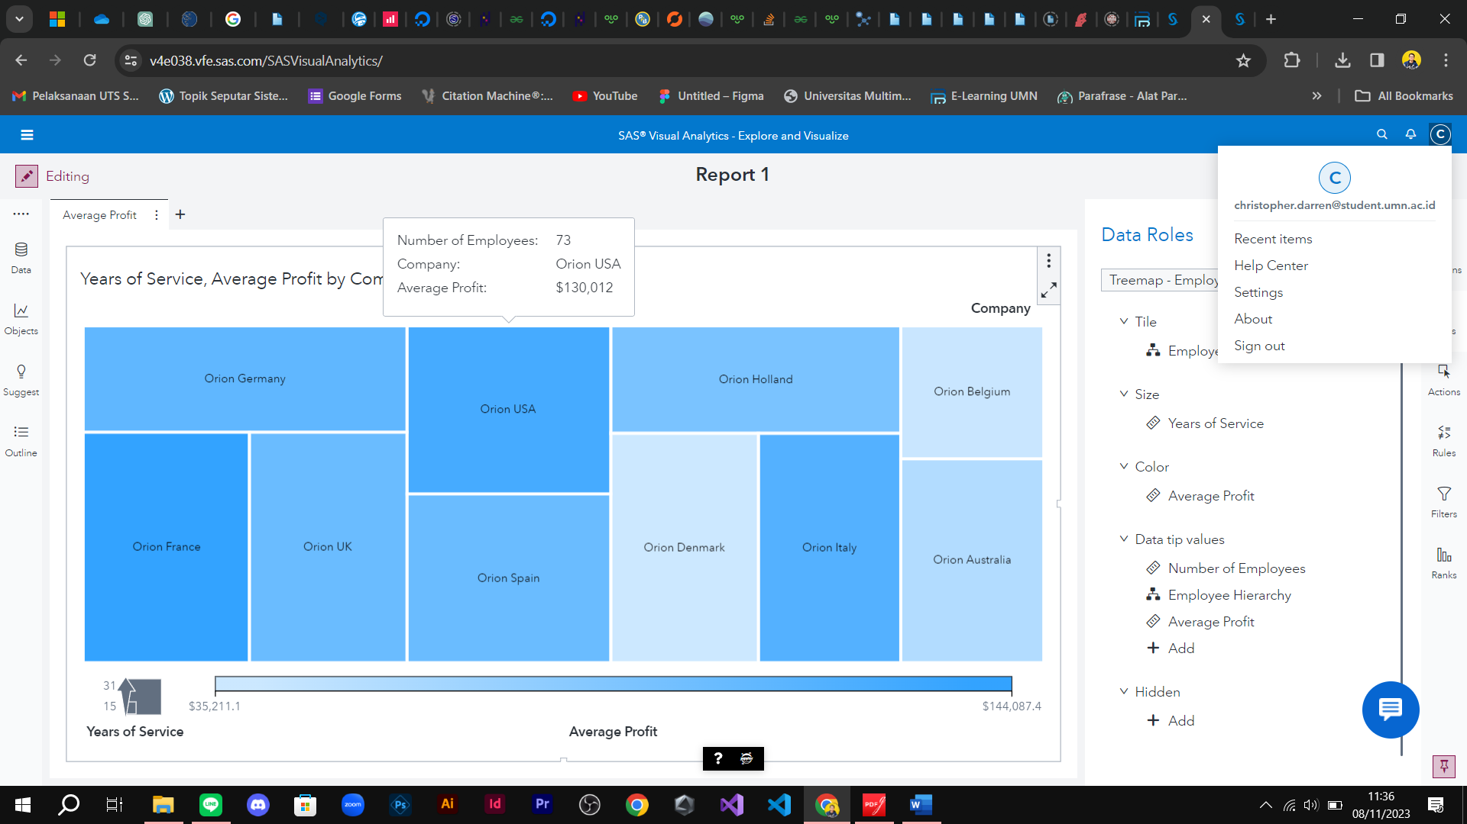

1. For these two companies, which job titles have the highest average years of service and average profit generated?

For Orion France = Sales Rep.IV **average years of service : 36 , average profit generated: 189,246**

Image of your reported answer

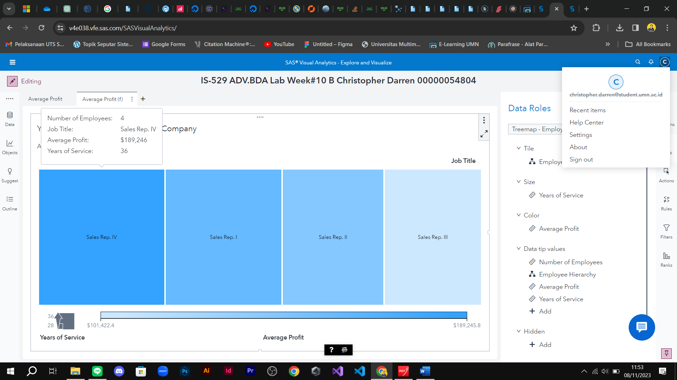

For Orion US = Sales Rep.II **average years of service**: 30 , **average profit generated**: 164,785

Image of your reported answer

